**Module 6: Critical Thinking**

Bipin Shrestha

Colorado State University Global

CSC405: Graphics and Visualization

Dr. Muhammad Khan

March 23, 2024

**Discussion on Sphere object**

A sphere is a three-dimensional object characterized by its perfectly round shape, where all the points on the surface are equidistant from the center. It is used extensively in computer graphics to demonstrate shading calculations. Understanding how light interacts with the surface of the sphere is crucial for analyzing accurate shading calculations. We can utilize vector computations to determine the intensity and direction of light rays at different points on the sphere's surface. The dot product between the vectors of the surface normal and light direction vector helps to determine how much light is reflected in each point, which also contributes to the shading of the sphere. Additionally, the sphere's curvature dictates how light is distributed across its surface, creating smooth transitions between shaded regions, and illuminated areas.

**Reflection**

Developing interactive approximated and recursively subdivided spheres within a 3D graphics environment using WebGL was an enriching experience. It was challenging, but I gained a deeper understanding of shading and reflection calculations. In the context of shading, it is crucial in creating the appearance of 3D objects. It is essential to understand the various shading models like Phong or Gouraud shading and how they affect the perception of light and shadow on curved surfaces to impact the visual appearance of the sphere and get satisfactory results. Additionally, understanding how to effectively shade a sphere involves grasping concepts such as diffuse, specular, and ambient lighting.

In the context of recursion, it is often utilized in computer graphics to create the illusion of depth and complexity in 3D scenes. In my program, I employed recursion to subdivide the sphere's surface into smaller triangles, resulting in smoother surfaces with more intricate textures. Experimenting with different shader techniques and recursion algorithms allowed me to explore the trade-offs between visual quality and efficiency. Balancing the level of recursion depth and computational resources was a challenge, especially when aiming for real-time interactivity.

Github: https://github.com/bipin-shrestha/CSC405-Module6.git

Program Executed:   
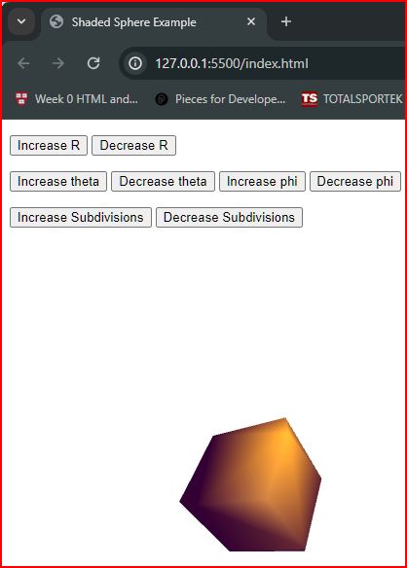

Github link: <https://github.com/bipin-shrestha/CSC405-Module5/blob/master/Ortho-ColoredCube.html>